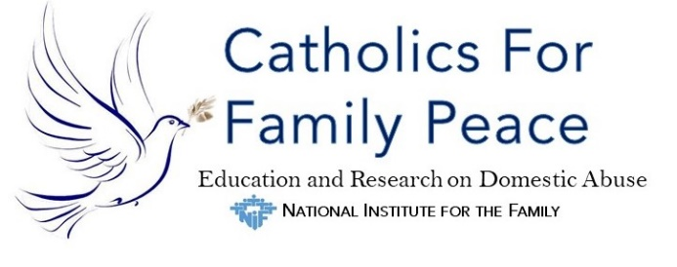

Ministering with Families Under Stress
Backgrounder
2023

As the stresses associated with the COVID-19 pandemic continue to impact families, domestic abuse and violence are taking an increasing toll on children and adults. Catholics For Family Peace Education and Research on Abuse offers assistance with education and resources for communities to promote peace within families. CFFP is not a direct service provider, but it works with parishes, dioceses and other organizations to help people and communities to prevent, recognize and respond with compassion to domestic abuse.
Downloadable Resources
How Can We Help to End Violence in Catholic Families: A Guide for Clergy, Religious and Laity – a 100-page illustrated booklet by Dr. Christauria Welland with imprimatur from the Diocese of San Diego, California, on violence in Catholic families, how to respond to and prevent violence, and how to educate Catholic youth and couples for peace. Available in six languages.

Safety information and restroom signs: Information that can be posted in restrooms, where victims of abuse and violence may safely learn how to protect themselves.

Prayers: Individual prayers, an invitation to a daily prayer at 3 p.m., a novena, prayers of the faithful and other resources.

A toolkit: Created for Domestic Violence Awareness Month in October, this toolkit includes material that can be used any time. Components include: basic facts, how to recognize abuse and how to respond, social media resources and preaching aids. Available in English or Spanish.

Marriage Preparation Course Module: Link to an order form for a 30-minute module for marriage preparation courses. It defines domestic abuse, explains Catholic teaching, and identifies ways to spot signs of domestic violence so that couples can avoid it. Includes a questionnaire for participants to share with their partners as well as group discussion options. Available in English, Spanish and French.
2020 Statistics. Even before the added stress and isolation of COVID-19, one in four women and one in nine men experienced severe intimate partner physical violence. Source: National Coalition Against Domestic Violence.
Interfaith Collaboration. CFFP is an active participant with Jewish, Christian, Muslim and other faith partners in the Interfaith Coalition Against Domestic Violence. Learn about their activities and how to participate in your community.
Activity Suggestions
Co-host DV Awareness Month Partnership with the U.S. Conference of Catholic Bishops Secretariat on Laity, Marriage, Family Life and Youth. To date,13 dioceses and archdioceses and 17 Catholic organizations collaborate to promote DV Awareness during October with special Masses, educational events, and resources. The DVAM Partners recently compiled these Covid DV Awareness Resources.
Organize Annual DVAM Mass. Normally celebrated at the National Shrine of the Immaculate Conception in Washington, D.C., due to COVID-19, the 2020 Mass was celebrated by Bishop Mark Brennan at St. Joseph Cathedral, Diocese Wheeling-Charleston. Watch Bishop Brennan's homily.
CFFP Refers Survivors and Abusers to Expert Helpers. Access to local Help is available 24/7 through the National Domestic Violence Hotline:1-800-799-SAFE (7233), 1-800-787-324 (TTY) or online by chat at http://www.ndvh.org.

CFFP is an initiative of the National Institute for the Family, a registered nonprofit education and research organization, part of the Archdiocese of Washington-DC.

Contact: Executive Partners
Sharon O'Brien, Ph.D., Director - 301-651-8190
Lauri Przybysz, D.Min, Education Director – 443-742-9699
catholicsforfamilypeace@gmail.com
catholicsforfamilypeace.org/
101 Idlewilde Rd, Severna Park, MD 21146
@CatholicFamilyPeace
@CFFamilyPeace

